Project Design Phase-II
Technology Stack (Architecture & Stack)

Date | 20 February 2026
Team ID | LTVIP2026TMIDS42531
Project Name | ShopEZ:One-Stop Shop for Online Purchases
Maximum Marks | 4 Marks

Technical Architecture:
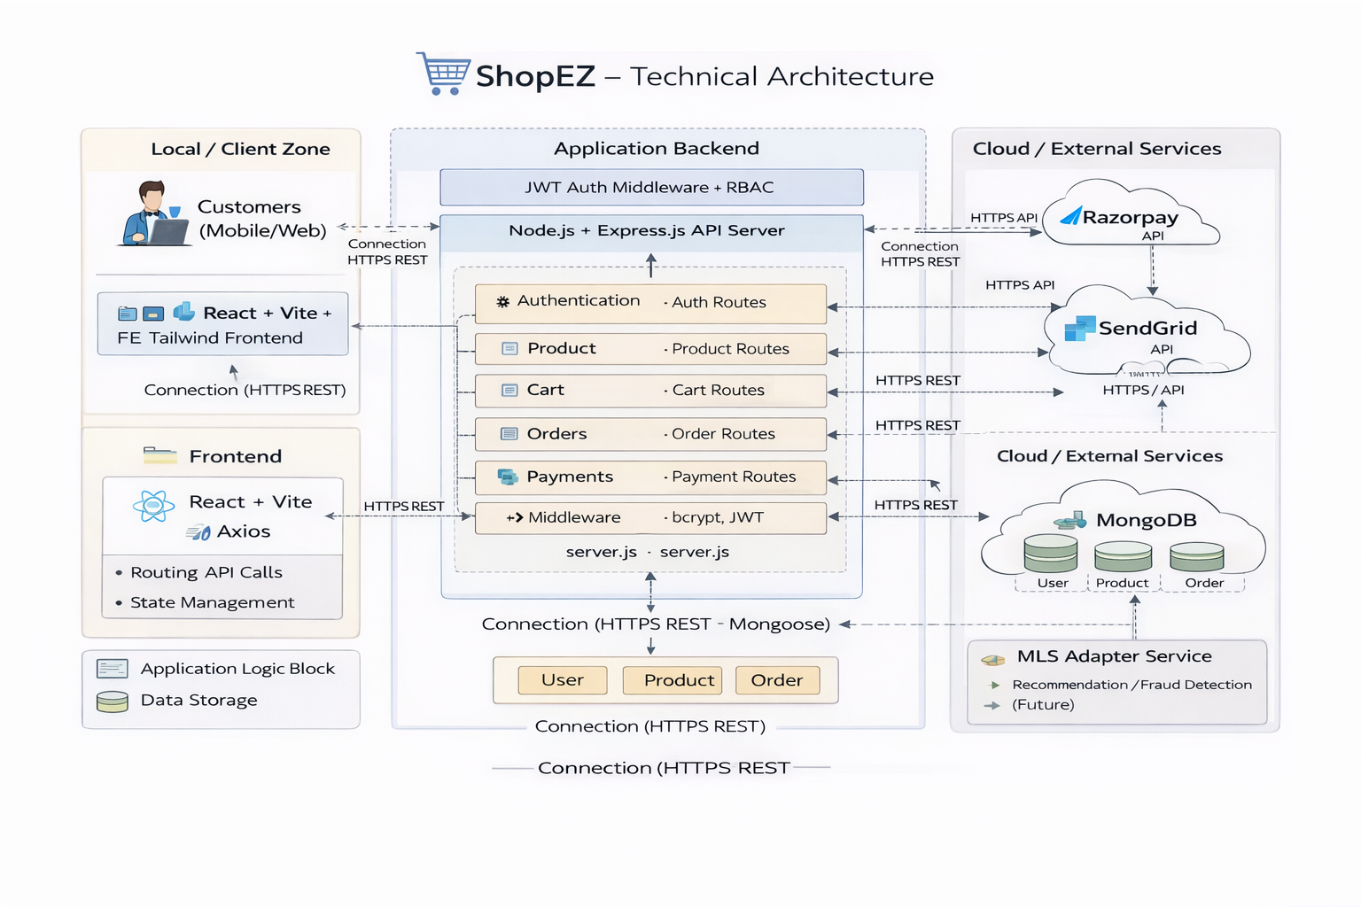

Table-1 : Components & Technologies:
S.No | Component | Description | Technology Used
1 | User Interface | Web interface for customers and admin to browse products, manage cart, and orders | HTML, CSS, JavaScript, React.js, Vite, Tailwind CSS
2 | Application Logic-1 | Backend business logic for authentication, product, cart, and order management | Node.js, Express.js
3 | Application Logic-2 | Authentication & security handling | JWT (JSON Web Token), bcrypt
4 | Application Logic-3 | Payment processing logic | Razorpay API Integration
5 | Database | Stores users, products, carts, orders, payments | MongoDB (NoSQL)
6 | Cloud Database | Cloud-hosted database service | MongoDB Atlas
7 | File Storage | Storage of product images | Local File System / Cloud Storage (if deployed)
8 | External API-1 | Online payment processing | Razorpay Payment Gateway API
9 | External API-2 | Email notifications (if implemented) | NodeMailer / SMTP (if used)
10 | Machine Learning Model | (Future Scope – Recommendation System) | Not implemented / Future AI module
11 | Infrastructure (Server / Cloud) | Application deployment environment | Local Server (Node.js), MongoDB Atlas Cloud

Table-2: Application Characteristics:
S.No | Characteristics | Description | Technology Used
1 | Open-Source Frameworks | The application is built using open-source frontend and backend frameworks for flexibility and cost efficiency. | React.js, Vite, Tailwind CSS, Node.js, Express.js, MongoDB
2 | Security Implementations | Secure authentication and protected APIs using token-based authentication and password hashing. | JWT (JSON Web Token), bcrypt, HTTPS, Role-based access control (RBAC)
3 | Scalable Architecture | Follows a 3-tier architecture (Frontend – Backend – Database) which allows scaling backend and database independently. | MERN Stack, MongoDB Atlas (Cloud DB)
4 | Availability | Application is accessible via web and can be deployed on cloud platforms for high availability. | Node.js Server, MongoDB Atlas Cloud
5 | Performance | Optimized API calls, lightweight frontend using Vite, efficient database queries using MongoDB indexing. | Axios (API calls), MongoDB Indexing, Vite build optimization

References:
https://c4model.com/
https://developer.ibm.com/patterns/online-order-processing-system-during-pandemic/
https://www.ibm.com/cloud/architecture
https://aws.amazon.com/architecture
https://medium.com/the-internal-startup/how-to-draw-useful-technical-architecture-diagrams-2d20c9fda90d

